Name:………………………………………............... Teacher …………………… Date …….
Gr12 Conservation of Momentum Practical (cf. p32 Text for Prac)
Theory: P= momentum = mass × velocity unit: kg.m.s⁻¹

Aim: To show that linear momentum is conserved when two trolleys explode apart.
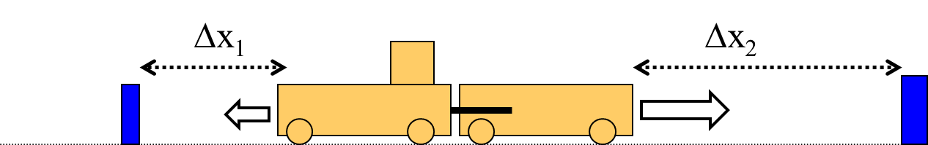
Method:

- Two trolleys are placed against each other on a smooth horizontal surface.
- The loaded spring is released on the one trolley and they explode apart.
- Successive measurements are made after varying the mass of the one trolley, by adding mass pieces each time.
- Stopping blocks are adjusted each time until they collide simultaneously.
- The relative distances (∆x) travelled by the two trolleys are recorded each time.
- Record the measurements (masses and displacements) in the table below.
- Calculate the relative mass x displacement values for each trolley and compare their magnitudes.
Results:
Trolley 1 |  |  | Trolley 2 |  |  | Total P after | % error
m₁ (kg) | ∆x₁ (m) | m₁∆x₁ (kg.m) | m₂ (kg) | ∆x₂ (m) | m₂∆x₂ (kg.m) | m₁∆x₁ + m₂∆x₂ | $$e.g.\frac{0.02×100}{0.920}$$  = 2.2 %
1.059 | 0.869 | 0.920 | 1.031 | - 0.873 | - 0.900 | +0.020
1.059 | 0.869 | 0.920 | 2.031 | - 0.448 | - 0.910 | +0.010 | 1.1 %
1.059 | 0.869 | 0.920 | 3.031 | - 0.300 | - 0,909 | +0.011 | 1.2 &
✓     ✓    ✓    ✓    ✓      ✓ (6)
Questions: Use the space below and overleaf
- What is the momentum of the system before the explosion? 0 kg.m.s⁻¹ ✓ (1)
- What conclusion can be made from the above observations? (2)
Conclusion: (Always talks to the Aim or investigative question) Within experimental error the conservation of linear momentum has been conserved. ✓✓ Error only 2.2%

- Explain (in a paragraph with equations) why we are justified in making conclusions about the conservation of momentum even though velocity is never measured? (3)
Theory:$P= momentum = mv = m∙\frac{∆x}{∆t}$
Velocity is not measured in this experiment. During each measurement however, the two trolleys travel for the same length of time.
Now: Momentum before = P _{before} = P_{trolley 1} + P_{trolley 2} = m₁v₁ +m₂v₂ = 0 , since neither are moving.
To show that momentum is conserved we need to show that momentum after the explosion also adds to zero. The one direction is positive the other is negative. If the magnitudes of the trolley’s momentum are equal then they will add to zero. In other words the magnitudes must be equal. So we can write
Momentum after = P_{after}=P_{trolley 1} + P_{trolley 2} = m₁v₁ +m₂v₂ = 0 = P _{before} OR since velocities have opposite signs: magnitude of m₁v₁ = magnitude of m₂v₂
i.e. $∴\frac{m_{1}∙∆x_{1}}{∆t}=\frac{m_{2}∙∆x_{2}}{∆t} now×∆t both sides$ since ∆t is the same
$$m_{1}∙∆x_{1}=m_{2}∙∆x_{2}$$
$$thus we eliminate∆t from the equation and having to measure it$$
$which is another source of experimental error$ ✓✓✓

- State the law of conservation of momentum. (2)
- In an isolated or closed system Total Linear Momentum is conserved. ✓✓

- Most versions of the law refer to a “closed system”. What exactly does this mean? (1)
- “closed system” means being able to account for all the pieces ✓ involved in the collision or explosion.
- It does not mean the same thing as the isolated or closed system involved in the Law of Conservation of Mechanical Energy. There the isolated system means no external or non-conservative forces. In conservation of momentum there can be forces like friction.

